Zonal Security
Security Officer Instruction Manual

Zonal Systems LLC.
February 10, 2014

Table of Contents

Downloading Test Flight and the Zonal Security Apps 2
Signing On to Zonal Security 3
Clocking in at a Location 4
Starting a Tour 5
Confirming Tour Orders and Proceeding on Tour 6
Checking in at a Checkpoint 7
Switching from Home view to Map View 10
Optional Settings & Features 11

Download the App for Beta Testers
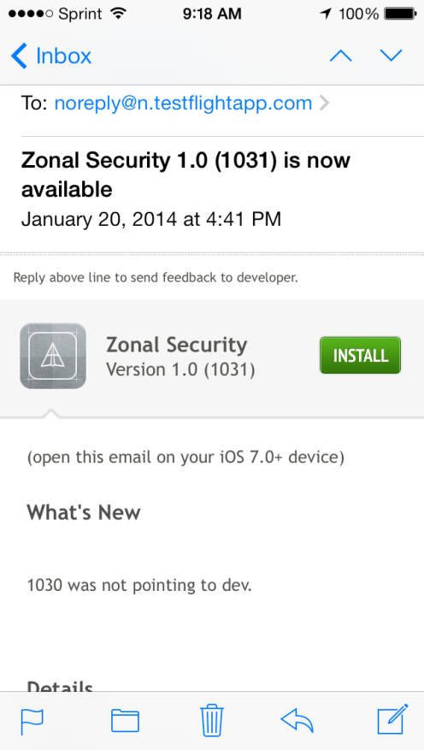
Most users will be downloading the app from the app store when it becomes available there. Currently it is not available at the app store and is only available to our Beta testers through our Test Flight distribution system.
If you are a Beta Tester, you will receive an email similar to the one on the left when you first enter the Beta program. Click the “Install” button on this first email and it will install Test Flight app on your iPhone. Once Test Flight is installed on your phone you will be able to install versions of Zonal Security.
Thereafter you will receive subsequent emails announcing new versions of Zonal Security along with the version number and edit number. When you receive these emails, you may again touch the “Install” button” and the Zonal Security app will be installed.
When the Zonal Security app is installed, we recommend you move it to your first screen for each access.
Signing On to the Zonal Security System
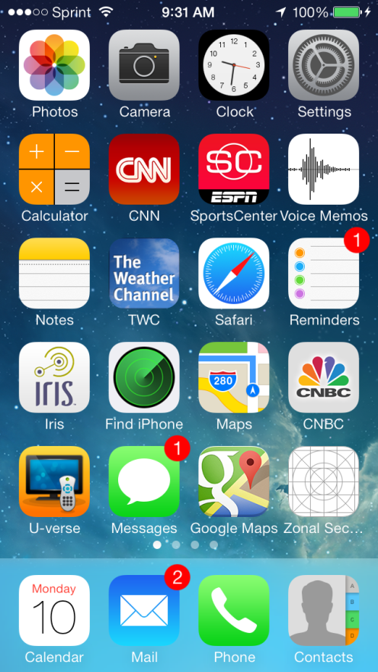
Go to your smart phone and find the Zonal Securiy Icon. In this example it is in the bottom right corner. Touch the Zonal Security Icon to start the program.
Figure 1

Touch Zonal Security to start program.

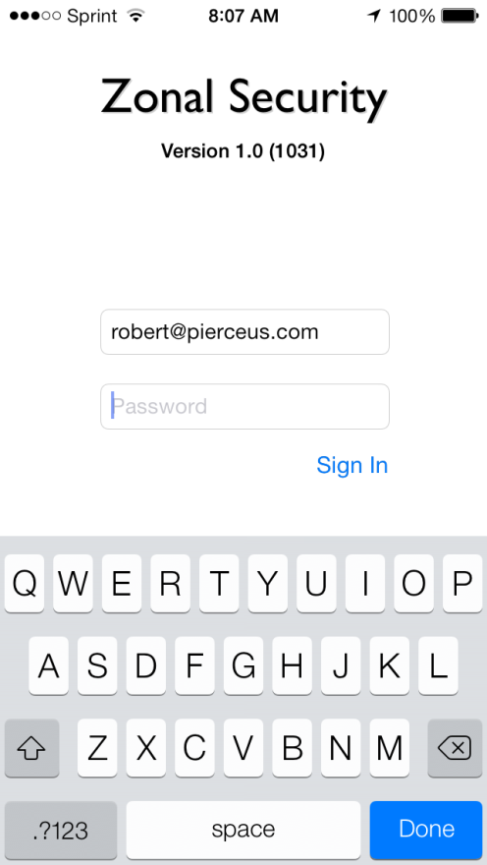
After you touch the Zonal Security Icon you will see the Sign In screen. Enter your ID and password (normally your email address assigned by your supervisor). When you are done touch “Sign In”
We have designed a sample tour that a Supervisor can set up for the Officer to try. It can be done at a nearby intersection of two streets. Simply set up checkpoints on each of the 4 corners of the intersection as shown in the example below.
Enter the user ID that has been provided to you here.
Enter your password here.

Touch keys on keyboard to enter User ID and password.

Clocking In to a Location
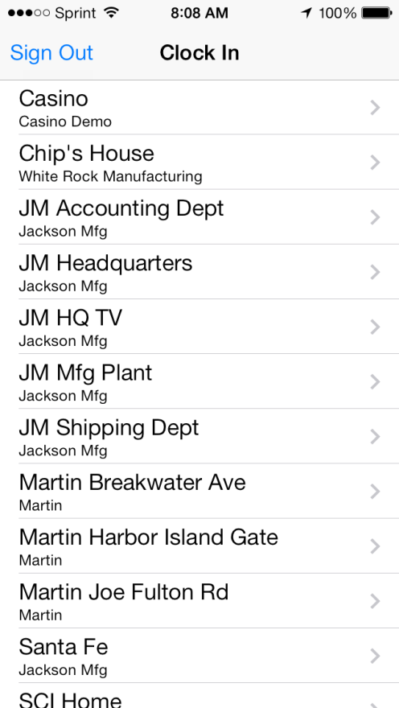
Once you have Signed In you will be presented with a number of locations where you can clock in. Your supervisor will assign you to locations.
Decide which location you are at and touch it to Clock in at that location. The locations are listed in alphabetical order. If you do not see your location, simply scroll the screen up or down. Once you touch a location to Clock in, you are “on the clock” for payroll purposes.
It is important to note that you must be “Signed In” to either Clock In or Clock Out. However once Clocked In, you can Sign Out and Sign In without having to Clock Out. This feature enables an number of features including the ability to change phones if one runs out of power.
In some cases, Zonal Security will prevent you from clocking in to a location if you are not actually at that location.
In this example I am going to Clock In to JM Headquarters. To choose that location, I touch JM Headquarters.
Touch JM Headquarters

When you touch JM Headquarters, the next screen displays any specific orders for that location. After you have read the orders touch “Confirm Orders” to continue.
Starting a Tour
Touch Confirm Orders to continue.

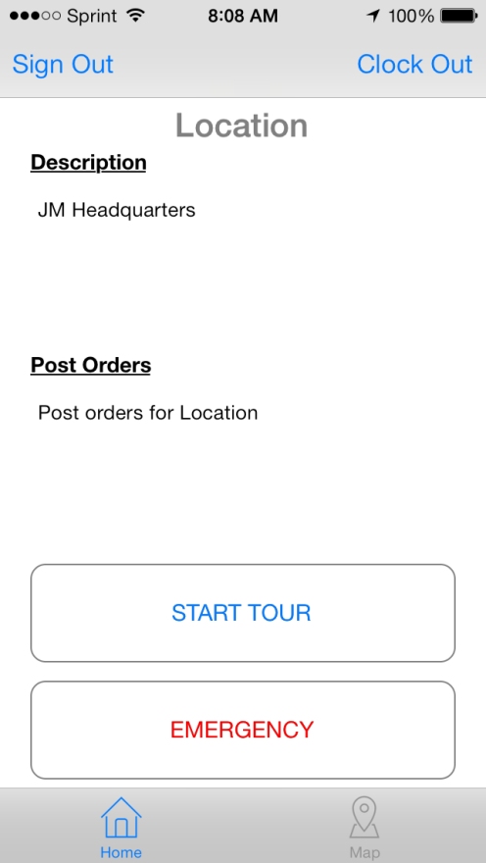
When you touch “Confirm Orders” on the previous screen you will be Clocked In to the chosen location and the Home screen will be displayed. In this case you will be clocked in to the JM Headquarters location.
The orders for the location are redisplayed

When you are ready to start a tour, touch “Start Tour”.
.
If an emergency situation should arise press “Emergency” and notifications will be sent out according to how your Supervisor has set them up.

To switch to Home view touch “Home”.
To switch to Satellite (Map) view touch “Map”.

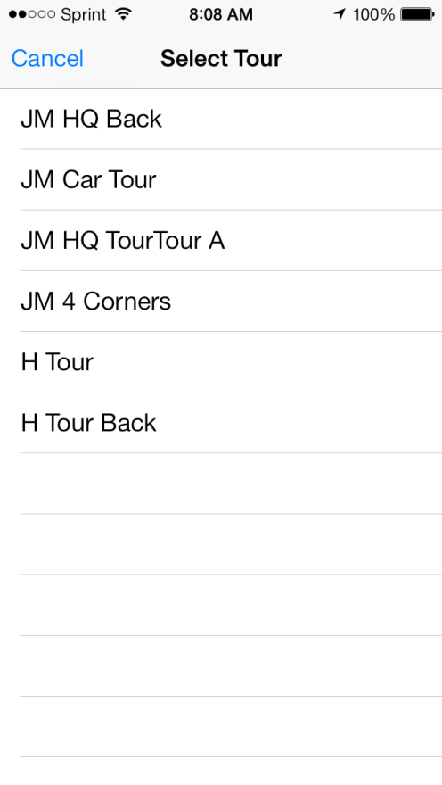
When you touch “Start Tour” you will be given a choice of tours to select.
In this example the “JM 4 Corners” tour is selected. This is an example tour. Each checkpoint on the tour is a corner of the intersection of two streets. The corners are NorthEast, SouthEast, SouthWest and NorthWest.

You will be able to see each of the checkpoints (corners) on the Map view.

Confirming Tour Orders and Proceeding on Tour
When you touch the “JM 4 Corners” tour on the previous screen you are taken to the post orders screen for the JM 4 Corners tour.
You will see the post orders displayed for the JM 4 Corners tour. nce you have read the orders, touch “Confirm Orders” to proceed on the tour.

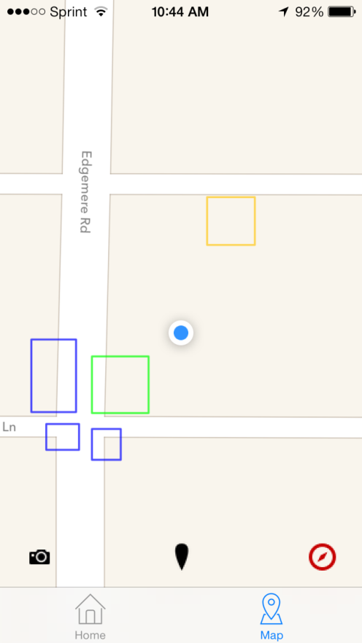
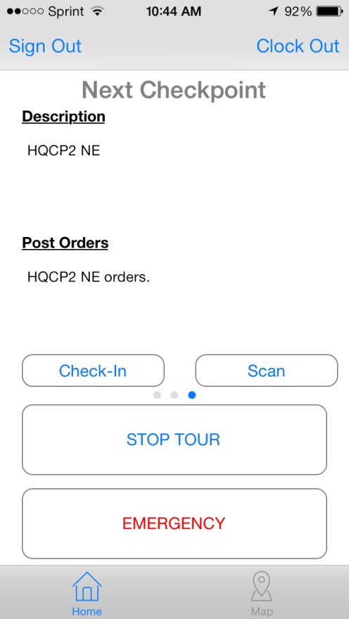
Once the tour is started the next checkpoint to visit is displayed on the screen along with the post orders. The next (HQCP2 NE) checkpoint is shown in green on the map. All others are shown in blue.

Check in is normally automatic. In some cases you may need to manually check in or scan a bar code using the appropriate buttons.
The top of the screen is North.
Officer Position
Home View Map View
Checking in at a Checkpoint
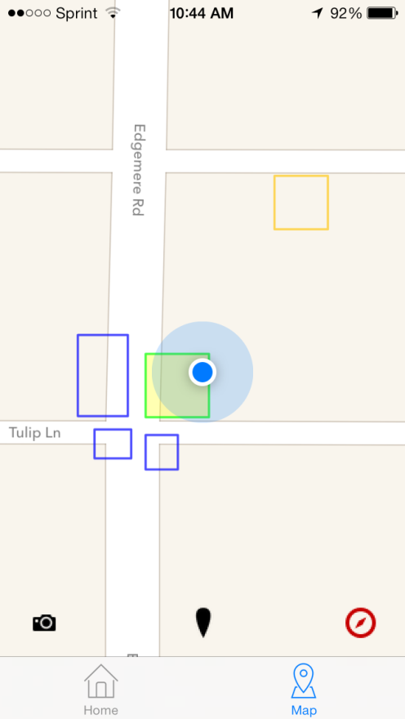
At any time during the tour you may switch between Home view and Map view. We will continue on the tour in Map view.
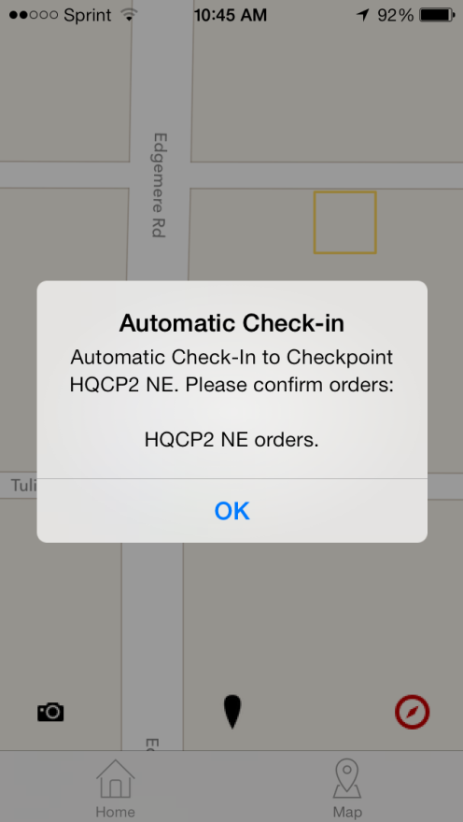
When the Officer has first enters the correct Checkpoint zone (shown with a green border) the Checkpoint zone will turn yellow to indicate that he is in the zone.
When the Officer has been in the zone long enough (set by Supervisor) the officer will hear a “ding-ding” and the checkpoint will go gray indicating that automatic check-in has taken place as shown on the right. In this case, there are orders that must be responded to.
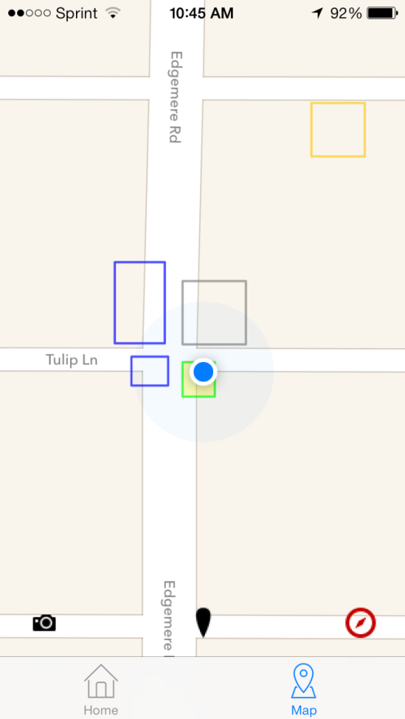
Touching the “Compass” button will center the map on the Officer and keep it centered as the Officer moves through the tour.
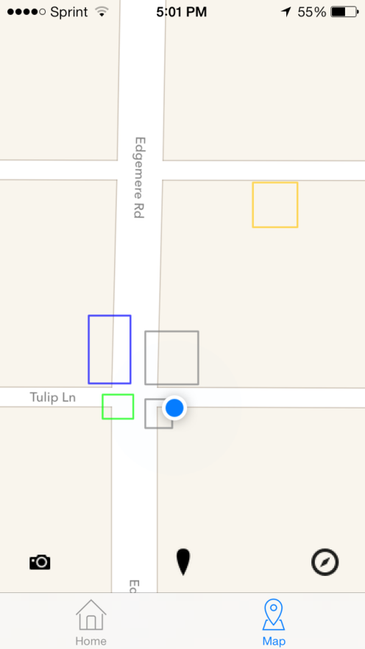
Touch OK and continue to the next Checkpoint Zone shown as a green box below.
Once automatic check-in has occurred at the SE checkpoint it turns gray, the SW checkpoint turns green and we proceed to the SW checkpoint.

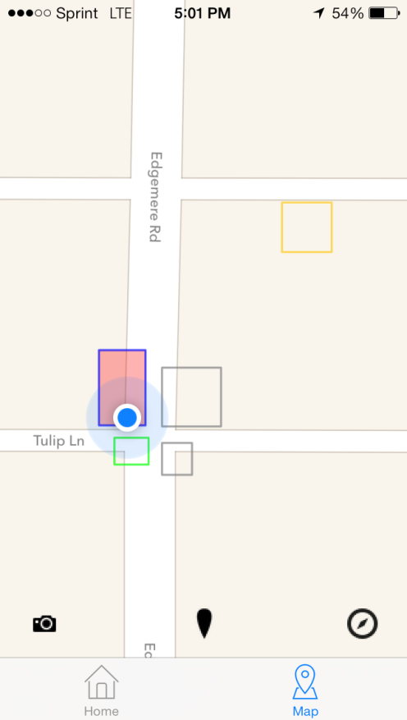
It is possible that an officer might proceed to the wrong checkpoint. In the example below he went to the NW checkpoint instead of the SW checkpoint. The NW checkpoint will turn red indicating that the Officer is in the wrong checkpoint. The green border SW checkpoint is the correct one.
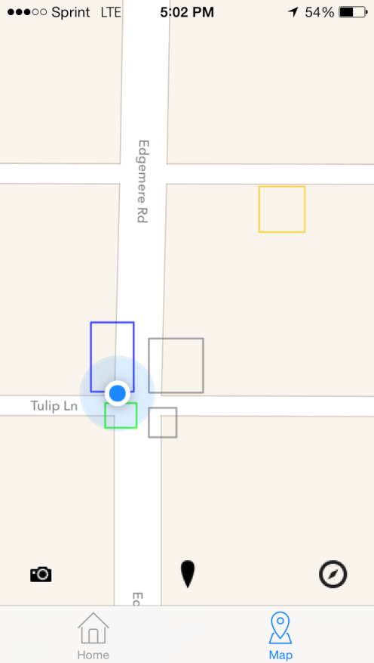

The Officer can proceed to the SW checkpoint for check-in.
As he proceeds out of the NW checkpoint the red indicator is gone.

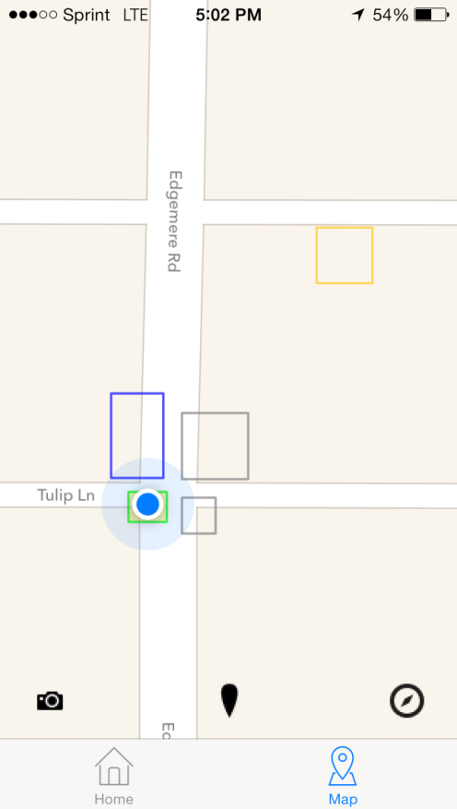
The Officer proceeds to the SW checkpoint and automatically checks in.

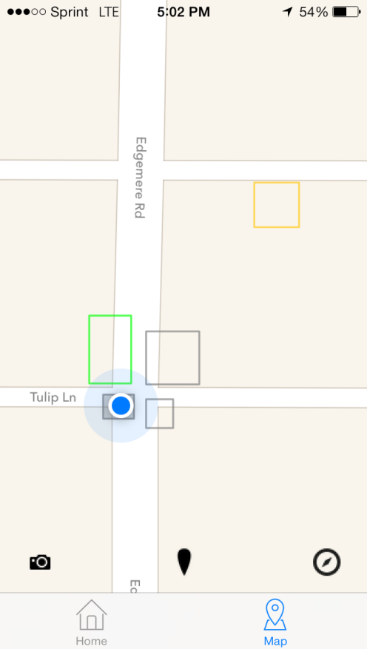

Once check-in occurs at the SW checkpoint, the NW checkpoint turns green and the tour continues.

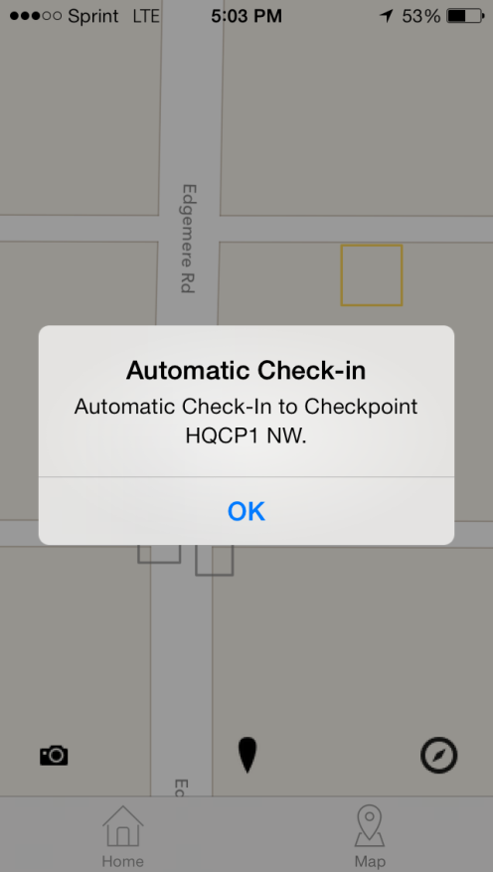
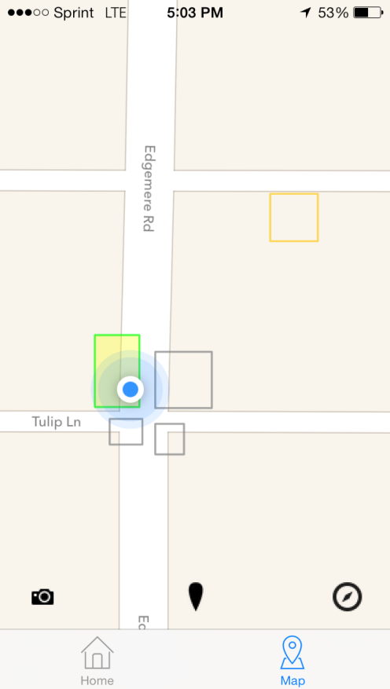
As the Officer proceeds to the NW checkpoint it turns yellow indicating that he has entered the zone.

Automatic Check-in occurs, the officer hears the check-in sound (ding-ding) and the checkpoint turns gray.
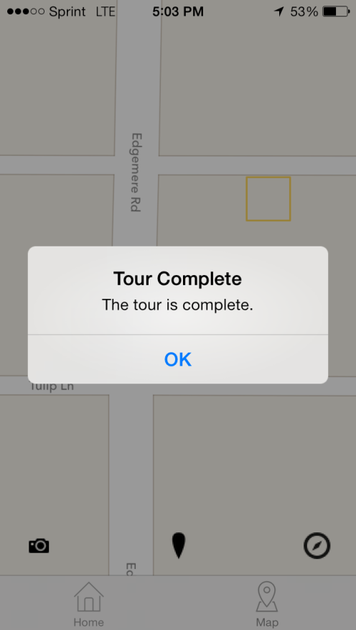
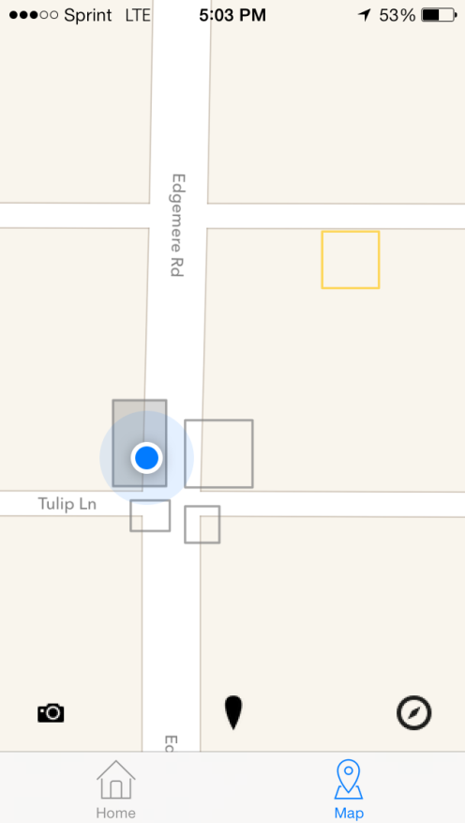

And the “Tour Complete” is displayed upon the screen. This last sequence of screens occurs very quickly. The time from the display of “Automatic Check-in” for the last checkpoint to the “Tour Complete” display ranges from about 10 seconds to 30 seconds.

Switching from Home view to Map View
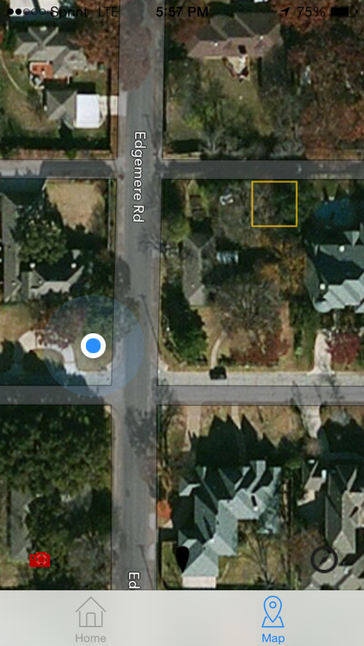
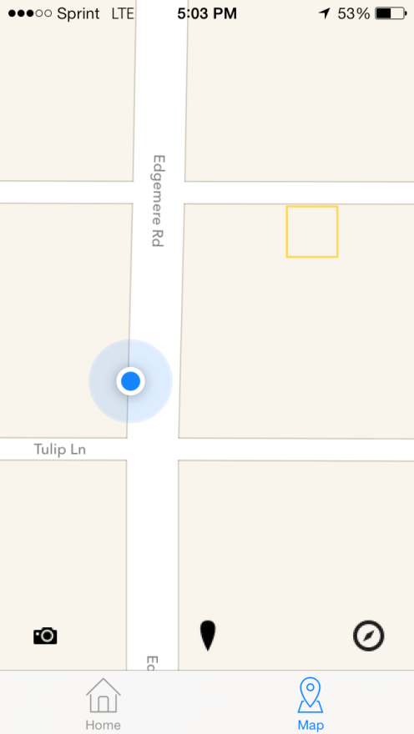
Once “Tour Complete” is displayed for about 10 seconds and the Officer hears the “Tour Complete” sound the display shows only the officer on the screen indicating that there are no more checkpoints to check-in on.

By touching the “camera” button in the bottom left corner the officer will see his location in a satellite view. If he is inside a building, he will most likely see rooftops.

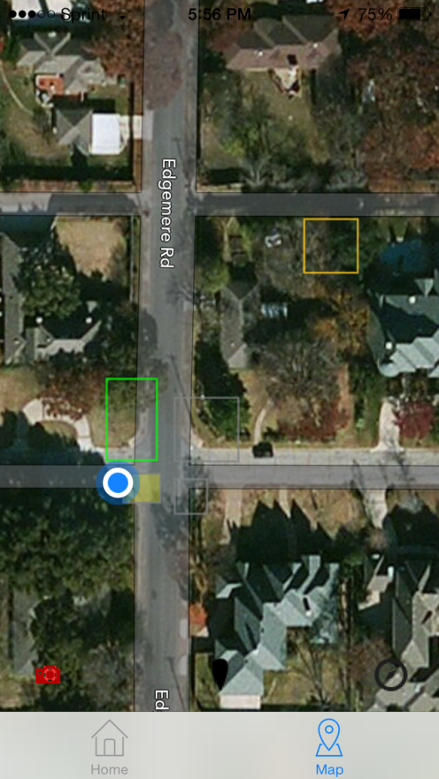
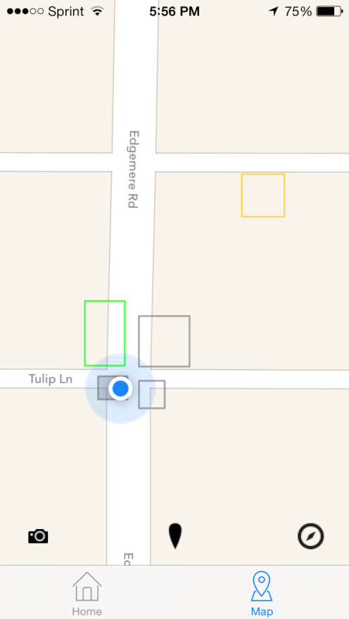
Let’s go back to when the Officer has just checked in to the SW checkpoint.
If he touches the “camera” button he will see all of the checkpoints and his location overlaid on a satellite view.

Optional Settings & Features
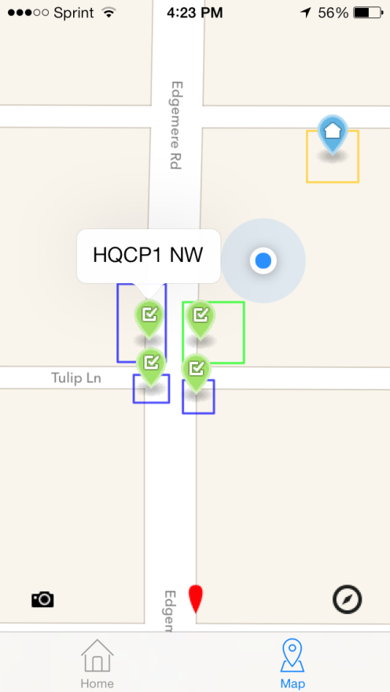
If you press the “pin” button you will see all of pin id’s for the checkpoint zones. The pin ID’s

Name of checkpoint

Pin ID’s

Pin Button

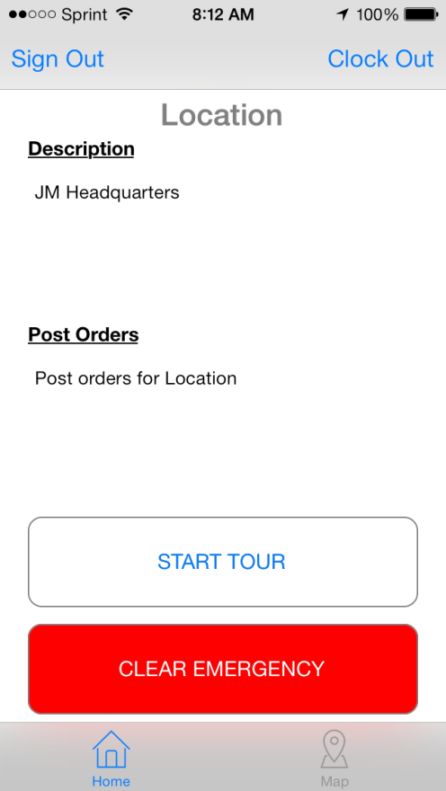
When the officer presses the Emergency button the emergency actions defined by the Supervisor are taken. This includes texting, email and automatic phone calls. To clear the emergency condition the officer should press the emergency button again.

